**TECHNOLOGY NAME: *Data Analysis with Cognos***

**PROJECT: *Public Health Awareness Campaign Analysis***

**PHASE NUMBER:4**

**INTRODUCTION:**

***In this phase we will continue building our project.***

* ***Continue building the analysis by creating visualizations using IBM Cognos and integrating code for data analysis.***
* ***Design dashboards and reports in IBM Cognos to visualize campaign reach, awareness levels, and impact metrics.***
* ***Use code Python to perform advanced data analysis, such as calculating engagement rates, conducting demographic analysis, or running statistical tests.***

**CODE:**

import pandas as pd

import numpy as np

import matplotlib.pyplot as plt

import seaborn as sns

import os

os.listdir("/kaggle/input/")

df = pd.read_csv("/kaggle/input/mental-health-in-tech-survey/survey.csv")

df.shape

df.info()

df.isna().sum()

self_employed_percent = (df["self_employed"].isnull().sum()/len(df["self_employed"]))*100

work_interfere_percent = (df["work_interfere"].isnull().sum()/len(df["work_interfere"]))*100

print(f"The percentage of missing values in self_employed column is **{**round(self_employed_percent, 2)**}**%")

print(f"The percentage of missing values in work_interfere column is **{**round(work_interfere_percent, 2)**}**%")

df["self_employed"] = df["self_employed"].fillna(df["self_employed"].mode()[0])

df["work_interfere"] = df["work_interfere"].fillna(df["work_interfere"].mode()[0])

df.drop(["state", "comments"], axis=1, inplace=True)

df.isna().sum()

df.columns

plt.figure(figsize=(17,5))

ax = sns.countplot(x='Country', data=df)

ax.set_xticklabels(

ax.get_xticklabels(),

rotation=45,

horizontalalignment='right'

for p **in** ax.patches:

ax.annotate(p.get_height(), (p.get_x()+0.25, p.get_height()+0.01), ha='center')

min_age = df["Age"].min()

max_age = df["Age"].max()

mean_age = df["Age"].mean()

median_age = df["Age"].median()

print(f"Min: **{**min_age**}**, **\n**Max: **{**max_age**}**, **\n**Mean: **{**mean_age**}**, **\n**Median: **{**median_age**}**")

df["Age"].unique()

negative_age = (df["Age"]<0).sum()

over_age = (df["Age"]>80).sum()

print(f"Number of negative age entries: **{**negative_age**}\n**Number of overage: **{**over_age**}**")

df.loc[df.Age<0, ["Age"]] = df["Age"].median()

df.loc[df.Age>80, ["Age"]] = df["Age"].median()

df["Age"].unique()

df.loc[df.Age<18, ["Age"]] = df["Age"].median()

df["Age"].hist()

import statistics

variance_age = df["Age"].var()

standard_dev_age = statistics.stdev(df["Age"])

print(f"Mean: **{**round(mean_age, 2)**}**"

f"**\n**Variance: **{**round(variance_age, 2)**}**"

f"**\n**Standard Deviation: **{**round(standard_dev_age, 2)**}**")

sns.set_style("whitegrid")

plt.figure(figsize = (8,5))

plt.title('Get Treatment of Survey Respondents', fontsize=12, fontweight='bold')

*#eda_percentage = df['treatment'].value_counts(normalize = True).rename_axis('treatment').reset_index(name = 'Percentage')*

ax = sns.barplot(x = 'treatment', y = 'Percentage', data = s4.head(10), palette='Purples')

for p **in** ax.patches:

width = p.get_width()

height = p.get_height()

x, y = p.get_xy()

ax.annotate(f'**{**height**:**.0%**}**', (x + width/2, y + height*1.02), ha='center', fontweight='bold')

def show_shap(col, shap_values=shap_values, label=main_label, X_test=X_test, ylabel='SHAP value'):

df_infl = X_test.copy()

df_infl['shap_'] = shap_values[:,df_infl.columns.tolist().index(col)]

gain = round(df_infl.groupby(col).mean()['shap_'],4)

gain_std = round(df_infl.groupby(col).std()['shap_'],4)

cnt = df_infl.groupby(col).count()['shap_']

dd_dict = {'col': list(gain.index), 'gain': list(gain.values), 'gain_std': list(gain_std.values), 'count': cnt}

df_res = pd.DataFrame.from_dict(dd_dict).sort_values('gain', ascending=False).set_index('col')

plt.figure(figsize=(9,6))

plt.errorbar(df_res.index, df_res['gain'], yerr=df_res['gain_std'], fmt="o", color="r")

plt.title(f'SHAP values for column **{**col**}**, label **{**label**}**')

plt.ylabel(ylabel)

plt.tick_params(axis="x", rotation=90)

plt.show();

print(df_res)

return

for col **in** X_test.columns:

print()

print(col)

print()

show_shap(col, shap_values, label=main_label, X_test=X_test)

output:

['mental-health-in-tech-survey']

(1259, 27)

<class 'pandas.core.frame.DataFrame'>

RangeIndex: 1259 entries, 0 to 1258

Data columns (total 27 columns):

# Column Non-Null Count Dtype

--- ------ -------------- -----

0 Timestamp 1259 non-null object

1 Age 1259 non-null int64

2 Gender 1259 non-null object

3 Country 1259 non-null object

4 state 744 non-null object

5 self_employed 1241 non-null object

6 family_history 1259 non-null object

7 treatment 1259 non-null object

8 work_interfere 995 non-null object

9 no_employees 1259 non-null object

10 remote_work 1259 non-null object

11 tech_company 1259 non-null object

12 benefits 1259 non-null object

13 care_options 1259 non-null object

14 wellness_program 1259 non-null object

15 seek_help 1259 non-null object

16 anonymity 1259 non-null object

17 leave 1259 non-null object

18 mental_health_consequence 1259 non-null object

19 phys_health_consequence 1259 non-null object

20 coworkers 1259 non-null object

21 supervisor 1259 non-null object

22 mental_health_interview 1259 non-null object

23 phys_health_interview 1259 non-null object

24 mental_vs_physical 1259 non-null object

25 obs_consequence 1259 non-null object

26 comments 164 non-null object

Timestamp 0

Age 0

Gender 0

Country 0

state 515

self_employed 18

family_history 0

treatment 0

work_interfere 264

no_employees 0

remote_work 0

tech_company 0

benefits 0

care_options 0

wellness_program 0

seek_help 0

anonymity 0

leave 0

mental_health_consequence 0

phys_health_consequence 0

coworkers 0

supervisor 0

mental_health_interview 0

phys_health_interview 0

mental_vs_physical 0

obs_consequence 0

The percentage of missing values in self_employed column is 1.43%

The percentage of missing values in work_interfere column is 20.97%

Timestamp 0

Age 0

Gender 0

Country 0

self_employed 0

family_history 0

treatment 0

work_interfere 0

no_employees 0

remote_work 0

tech_company 0

benefits 0

care_options 0

wellness_program 0

seek_help 0

anonymity 0

leave 0

mental_health_consequence 0

phys_health_consequence 0

coworkers 0

supervisor 0

mental_health_interview 0

phys_health_interview 0

mental_vs_physical 0

Index(['Timestamp', 'Age', 'Gender', 'Country', 'self_employed',

'family_history', 'treatment', 'work_interfere', 'no_employees',

'remote_work', 'tech_company', 'benefits', 'care_options',

'wellness_program', 'seek_help', 'anonymity', 'leave',

'mental_health_consequence', 'phys_health_consequence', 'coworkers',

'supervisor', 'mental_health_interview', 'phys_health_interview',

'mental_vs_physical', 'obs_consequence'],

dtype='object')

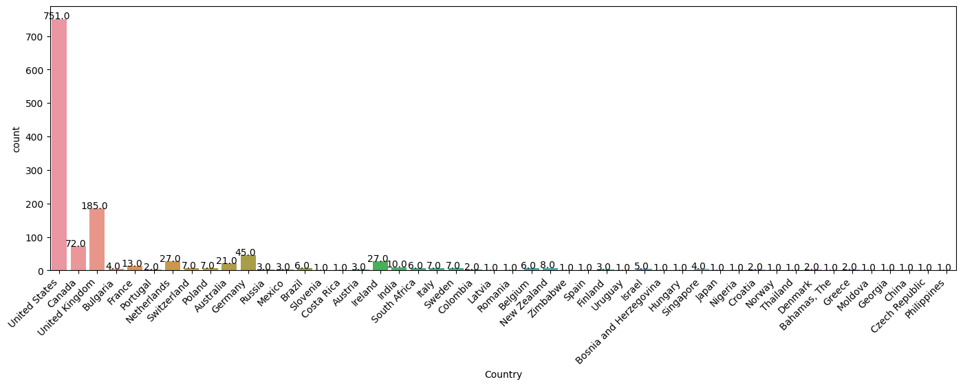

Min: -1726,

Max: 99999999999,

Mean: 79428148.31135821,

Median: 31.0

array([ 37, 44, 32, 31, 33,

35, 39, 42, 23, 29,

36, 27, 46, 41, 34,

30, 40, 38, 50, 24,

18, 28, 26, 22, 19,

25, 45, 21, -29, 43,

56, 60, 54, 329, 55,

99999999999, 48, 20, 57, 58,

47, 62, 51, 65, 49,

-1726, 5, 53, 61, 8,

11, -1, 72])

